SUCCESS INTEGRATED NURSERY SCHOOL
Internal End of First Term Examinations 2020
Intelligence 4-5 years

Name ________________________Stream__________
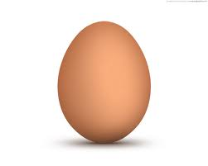

1. Match the belongings.

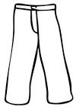

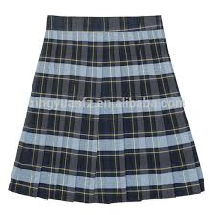




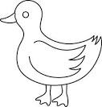


2. Circle the syllables only.

sat nat man cat k fan pat tap

3. Count the shaded objects.
= 3
= _____________
= ___________

= ____________
= ____________
4. Put the missing parts.

5. Tick (√ ) the correct letter.
m 3 $ε$
j
s
e

